**Micro Project On**: “**To study the Circuit of Full**

**Wave Bridge Rectifier.”**

**Course** – Basic Electronics.

**Courses Code**: 22225

**Academic Year**:2022-2023

**Semester:**2I

|  |  |  |  |
| --- | --- | --- | --- |
|  |  |  |  |
|  | 2201410261 | Ghorpade Tanvi Krishna | 531 |
|  | 2201410262 | Giri Shubham Dinesh | 532 |
|  | 2201410263 | Gujarathi Rushi Raviraj | 533 |
|  | 2201410264 | Gunjal Mansi Pravin | 534 |
| **5** | 2201410265 | Iyer Vishal Jaikanth | 535 |

**Name Of Micro Project Guide – Ms. Meera Dattatray Pawar**

ALL India Shri Shivaji Memorial Society’s Polytechnic,

Kennedy Road Near RTO, Pune-411 001

-------------------------------------------------------------------------------------------------------------------------------

------------------------------------------------------------------------------------------------------------------------------

**Certificate**

Certified that this Microproject report titled – “To study the circuit of Full -Wave bridge Rectifier is the bonafide work of **Ms/Mr. Ghorpade Tanvi, Giri Shubham, Gujarathi Rushi, Gunjal Mansi, Iyer Vishal** Roll no **531,532,533,534,535** of first year diploma in **Computer Engineering**.

Engineering of the Course: **Basic Electronic** Course code :**22225** during the academic year 2022-2023, Who carried out the micro project work under my supervision.

**MS. Meera Dattatray Pawar**

Name and Signature Subject Teacher

__________

|  |  |  |
| --- | --- | --- |
|  |  |  |
|  |  |  |
|  |  |  |
|  |  |  |
|  |  |  |
|  |  |  |
|  |  |  |
|  |  |  |
|  |  |  |
|  |  |  |
|  |  |  |

**Annexture I**

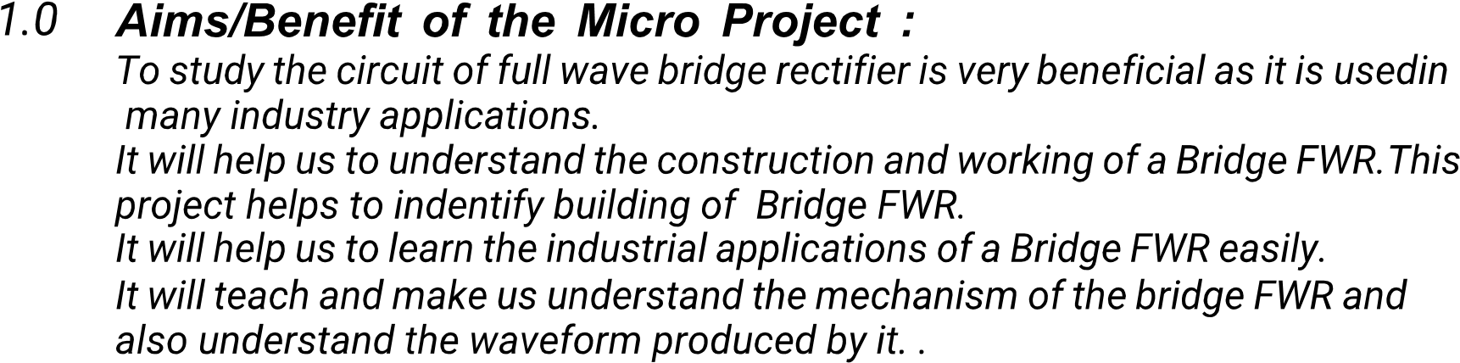

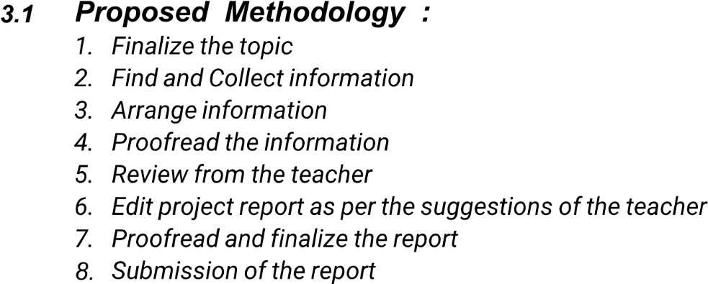

|  |  |  |  |  |
| --- | --- | --- | --- | --- |
|  |  |  |  | Name of the Responsible Team Member |
|  |  | 01-04-2023 | 01-04-2023 | All Team Members |
|  |  | 02-04-2023 | 07-04-2023 |  |
|  |  | 07-09-2023 | 10-04-2023 | Mansi Gunjal. |
|  |  | 11-04-2023 | 12-04-2023 | Tanvi Ghorpade |
|  |  | 12-04-2023 | 12-04-2023 | Vishal Iyer |
|  |  | 13-04-2023 | 15-04-2023 | Rushi Gujarathi |
|  |  | 16-04-2023 | 17-04-2023 | All Team member |
|  |  | 18-04-2023 | 18-04-2023 | All Team Member |

|  |  |  |  |
| --- | --- | --- | --- |
|  |  |  |  |
|  |  | https://byjus.com/physics/full-wave-rectifier  https://www.electrical4u.com/full-wave-rectifiers | To Collect Information of Full wave-bridge Rectifiers. |
|  |  | **2010 Power -Point.** | To make PPT On topic. |
|  |  | <https://www.youtube.com/watch?v=NQCxKdhxm4A> | To collect data and use for learn how to make model of Full wave bridge Rectifiers. |
| 4. | Apps | Paint and Camera | Images for the report were made /taken using. |

|  |  |  |
| --- | --- | --- |
|  |  |  |
|  | Ghorpade Tanvi Krishna | 531 |
|  | Giri Shubham Dinesh | 532 |
|  | Gujarathi Rushi Raviraj | 533 |
|  | Gunjal Mansi Pravin | 534 |
| 5. | Iyer Vishal Jaikanth | 535 |

**Annexture II**

**Micro Project Report**

**5.0 Rationale**: The Foundation for working of computer or any peripheral are based on electronics. It’s Important to develop skills to understand and test simple electronic components and circuits.

**6**.0 **Aims / Benefits of the micro-Project**:

**Aims:**

1**.converts the complete cycle of alternating current into pulsating DC.**

2. A full wave rectifier is used in signal modulation and in electric welding.

3. Full wave rectification is the main aim process of converting an AC signal to a DC signal.

**Benefits**:

1The efficiency of full bridge rectifiers is higher than that of half-wave rectifiers

2.A full bridge rectifier produces a smoother output than a half-wave rectifier.

3. For processing, the full bridge rectifier accepts both positive and negative half cycle s of the input AC signal. The half-wave rectifier lacks this functionality, processing only half of the AC signal while blocking the other.

**7.0 Course Outcomes Achieved:**

**CO:C22225a**: Identify Electronic Components in electronic Circuit.

**CO:C2225b**. Use Diodes in Different Applications.

**Co: C2225c.Use** Full- Wave Bridge Rectifier in different Applications.

**8.0 Literature Review:**

The Information about the Project was researched and noted from **Google.**

The PowerPoint Presentation was prepared using **Microsoft Office 2010 PowerPoint.**

The Model/Circuit was made using the reference of: **www.aiophotoz.com**

Images for the Report were made/taken using: **Paint and Camera Apps.**

Other reference information was collected using **Wikipedia.**

Information about Full Wave Bridge Rectifier: **google**

Information about Rectifier: **Google**

Reference about diagram/circuit: **google Images**

Concept about Full -Wave Bridge Rectifier. learn from: **YouTube.**



|  |  |  |  |
| --- | --- | --- | --- |
|  |  |  |  |
|  |  |  |  |
|  |  |  |  |
|  |  |  |  |
|  |  |  |  |
|  |  |  |  |
|  |  |  |  |
|  |  |  |  |
|  |  |  | Wave Rectifier. |
|  |  |  |  |
|  |  |  |  |
|  |  |  |  |
|  |  |  |  |
|  |  |  |  |
|  |  |  |  |
|  |  |  |  |
|  |  |  |  |

**10. Output of the microproject** :

a) Due to this project, the concept about Full -Wave Bridge Rectifiers we learned.

b) The working & operation of a full-wave bridge rectifier is pretty simple.  The circuit diagrams and waveforms we have given below will help you understand the operation of a bridge rectifier perfectly.

c)  In the circuit diagram, 4 diodes are arranged in the form of a bridge. The transformer secondary is connected to two diametrically opposite points of the bridge at points A & C.  The load resistance RL is connected to the bridge through points B and D. Full-Wave Bridge Rectifier – Circuit Diagram with Input and Output Wave Forms

### During the first half cycle:

a) During the first half cycle of the input voltage, the upper end of the transformer secondary winding is positive with respect to the lower end. Thus, during the first half cycle, diodes D1 and D3 are forward biased and current flows through arm

b) AB enters the load resistance RL, and returns back flowing through arm DC. During this half of each input cycle, the diodes D2 and D4are reverse biased and current is not allowed to flow in arms AD and BC. The flow of current is indicated by solid arrows in figure 1.2 above

c). We have developed another diagram below to help you understand the current flow quickly. See the diagram below – the green arrows indicate the beginning of current flow from the source (transformer secondary) to the load The flow of current in the Bridge Rectifier resistance. The red arrows indicate the return path of current from load resistance to the source, thus completing the circuit.

[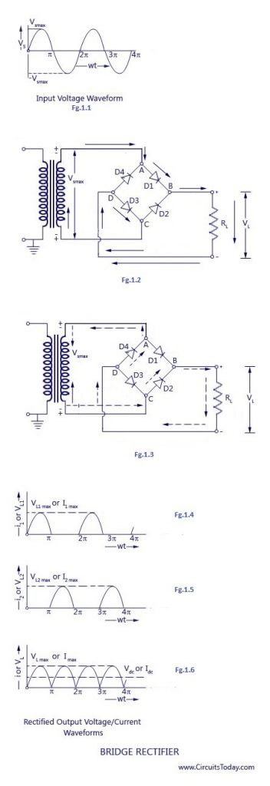](https://www.circuitstoday.com/wp-content/uploads/2022/04/bridge_rectifier.jpg)

[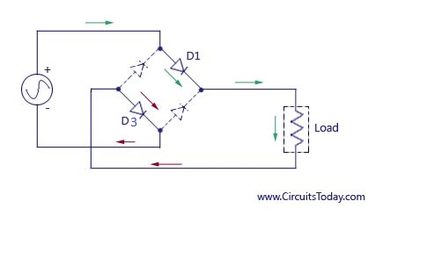](https://www.circuitstoday.com/wp-content/uploads/2009/08/current_flow_in_bridge_rectifier_1.jpg)

### During the second half cycle

a) During the second half cycle of the input voltage, the lower end of the transformer secondary winding is positive with respect to the upper end.

b) Thus, diodes D2 and D4 become forward biased and current flows through arm CB, enters the load resistance RL, and returns back to the source flowing through arm DA. The flow of current has been shown by dotted arrows in figure 1.3

c). Thus, the direction of flow of current through the load resistance RL remains the same during both half cycles of the input supply voltage.  See the diagram below – the green arrows indicate the beginning of current flow from the source (transformer secondary) to the load resistance

d). The red arrows indicate the return path of current from load resistance to the source, thus completing the circuit.

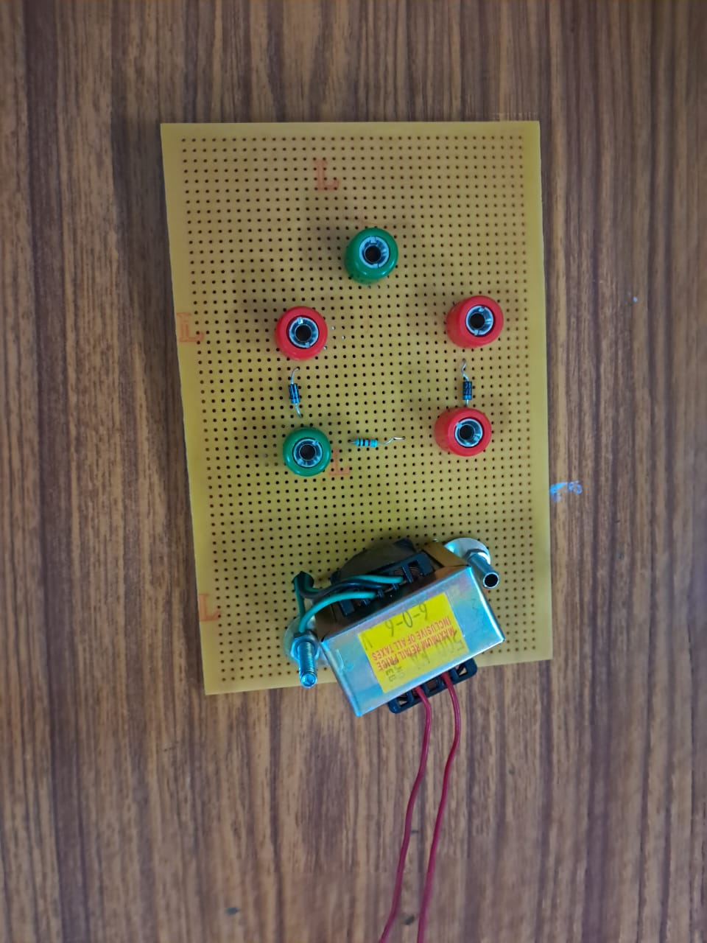

11.**Skill developed / Learning outcome of the Micro-Project: -**

1. Communication skills.
2. Time management.
3. Working in a team.
4. Following ethics.
5. Stress management.
6. Psychomotor skills such as making model/chart and its demonstration.
7. Presentation skills.
8. Upgrading knowledge of physics through activity.

**12.Application of the Micro-Project**:

Step 1: Understand Your Components

[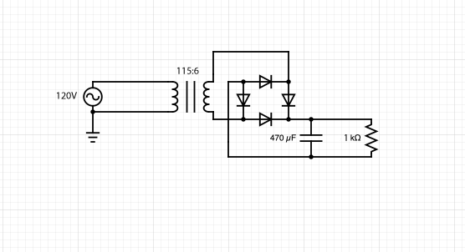](https://content.instructables.com/F8B/DRMX/K78SM7PO/F8BDRMXK78SM7PO.png?auto=webp&frame=1&fit=bounds&md=b8400be1eb5f7fcda56ac01cadf2a9a3)

Before beginning the assembly, it is important that we know how are components function and the correct way to arrange them.

First, remind yourself of how a breadboard works. The two rows on either side of the breadboard (between the red and blue lines) are the power rails are electrically connected along the length of the breadboard. Meanwhile, the inside rows are electrically connected along the width of the breadboard, but not across the divider in the middle. In this design, we will use the division in the middle to our advantage to spread out the components and make the circuit cleaner.

Next, be aware that the diodes only conduct in one direction, and it is necessary that the diodes are pointing in the right direction for the circuit to function. The diodes used in this project conduct from the black side to the silver side (referencing the schematic symbol for a diode, the silver side is the side that the "arrow" is pointing towards.)

Finally, note that the capacitor is direction specific as well, and that electricity should flow from the shorter leg to the longer leg of the capacitor.

[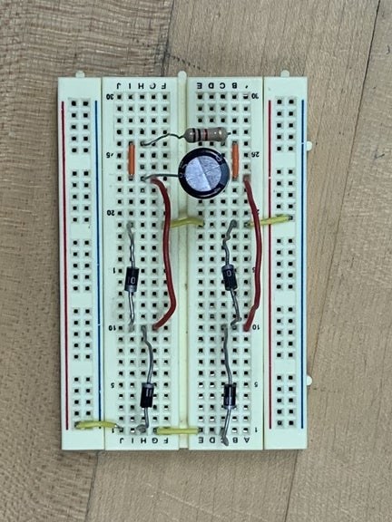](https://content.instructables.com/FHT/1ZRL/K78KRF14/FHT1ZRLK78KRF14.jpg?auto=webp&frame=1&fit=bounds&md=48aa082871e8a7229f97d1c8b3f3bbce)Step 2: Assemble the Circuit

[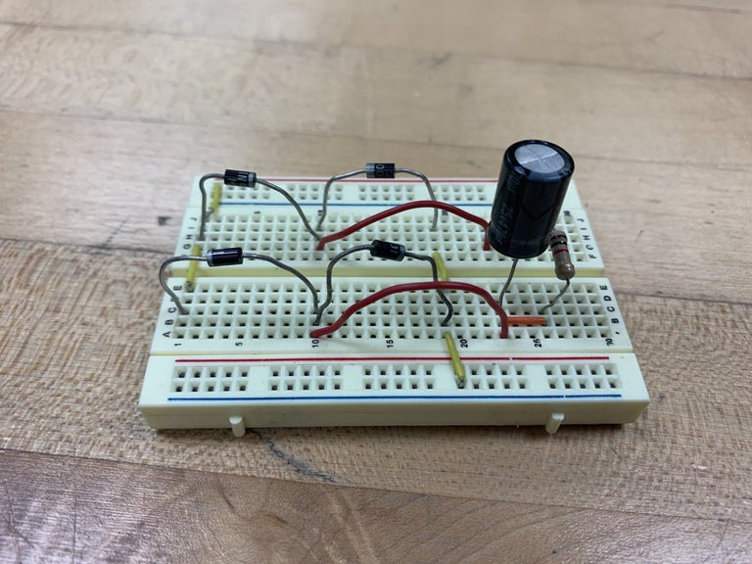](https://content.instructables.com/FIL/OV37/K7B6AHOK/FILOV37K7B6AHOK.jpg?auto=webp&frame=1&width=1024&fit=bounds&md=0727f9dadfd1eb54c3cefdb3da7ebf8c)

Now keeping the directions of the components in mind, assemble the circuit according to the schematic and photo provided. While the specific pins in which the components are inserted need not be the same as in the photo, the components must be electrically connected in the same way i.e., the components in the same rows in our circuit must be in the same rows as in yours.

Step 3: Connect to Transformer:

[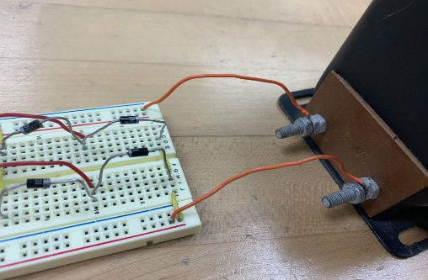](https://content.instructables.com/FMW/4RPB/K78KRH21/FMW4RPBK78KRH21.png?auto=webp&frame=1&width=1024&height=1024&fit=bounds&md=4319d8c39720a58efd149459b31cbf5b)

Using jumper wires, connect the power rails to the outputs of the AC transformer. For safety, make sure the transformer is not plugged in! For some transformers (such as the one used in the photo) it may be necessary to use a wrench or pliers to tighten nuts that connect the wires. This will power your circuit with 6V AC after it is transformed from the 120V AC that comes out of the wall. After you plug in the transformer, make sure if you smell something burning or smoking and immediately unplug the transformer.

Step 4: Test Your Circuit

[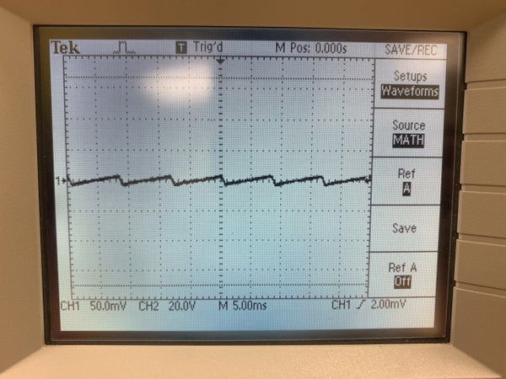](https://content.instructables.com/F8W/3CM0/K7B6AHKR/F8W3CM0K7B6AHKR.jpg?auto=webp&frame=1&width=1024&fit=bounds&md=f69e060d87052d6c681bc7201724ec3e)[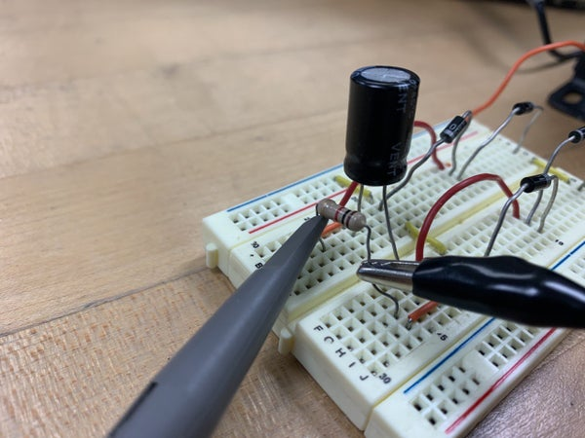](https://content.instructables.com/FJY/SO2U/K7B6AH4Q/FJYSO2UK7B6AH4Q.jpg?auto=webp&frame=1&width=1024&fit=bounds&md=f2969c63b8b32aa381e44fec06736aed)

At this point, the circuit should be functioning properly, but we are unable to tell unless we perform measurements. To do this, we will use the oscilloscope. Turn on your oscilloscope and connect the probe across the resistor on the circuit as shown in the photo. Adjust the scaling on the oscilloscope until you see a generally straight line at around 3.5 V with small ripples like in the photo above. These ripples are a result of the capacitor charging and releasing electricity.

Step 5: Troubleshooting/Tips:

First of all, when assembling this circuit, it is recommended that all the components are fairly spread out on the breadboard. This not only makes it easier to be organized in your assembly but also makes it less likely that two components touch and short the circuit. Also, be sure to press your wires and components are fully pressed down so that they form an electrical connection with the breadboard.

As emphasized in step 1, make sure all your components are orientated correctly, especially in the case of diodes since they only function in one direction.

If the output on the oscilloscope does not look correct, make sure the scaling is correct. It is recommended that you start with the autoscaling feature and go from there. If there is no signal, measure the output of the transformer to confirm that it is functioning properly. In general, it is good practice to test the signal across each component to find where the circuit has failed.